**Telemetrum / Telemega Flight Computer**

**Flight Computer**

Telemetrum v2.0 ----------------------------------------------------------------------------------------------------------------------------$300.00

* Recording altimeter for model rocketry
* Supports dual deployment (can fire 2 ejection charges)
* 70cm ham-band transceiver for telemetry downlink
* Barometric pressure sensor good to 100k feet MSL
* 1-axis 105-g accelerometer for motor characterization
* On-board, integrated GPS receiver
* On-board non-volatile memory for flight data storage
* USB for power, configuration, and data recovery
* Integrated support for LiPo rechargeable batteries
* Uses LiPo to fire e-matches, can be made to support separate pyro battery
* 2.75 x 1 inch board designed to fit inside 29mm airframe coupler tube

<https://www.apogeerockets.com/Electronics_Payloads/Altimeters/TeleMetrum> (sold by Apogee Components) **$321.00**  <https://www.csrocketry.com/store/search.html?search%5Bkeywords%5D=telemetrum&_a=category> (sold by Chris’ Supplies) **$300.00**

**OR**

Telemega --------------------------------------------------------------------------------------------------------------------------------------$400.00

* Recording altimeter for high power model rocketry
* Supports dual deployment and 4 additional pyro events.  
  Pyro events are configurable and can be based on time and various flight events and status, including angle from vertical (for safety in staging and air start flights).
* 70cm ham-band transceiver for telemetry downlink
* Barometric pressure sensor good to 100k feet MSL
* 1-axis 105-g accelerometer for motor characterization
* 3-axis 16-g accelerometer for gyro calibration
* 3-axis 2000 deg/sec gyros
* 3-axis magnetic sensor
* On-board, integrated GPS receiver
* On-board non-volatile memory for flight data storage
* USB for power, configuration, and data recovery
* Integrated support for LiPo rechargeable batteries
* User choice of pyro battery configuration, can use primary LiPo or any customer-chosen separate pyro battery up to 12 volts nominal.
* 3.25 x 1.25 inch board designed to fit inside 38mm airframe coupler tube

<https://www.csrocketry.com/store/search.html?search%5Bkeywords%5D=Telemega&_a=category> (sold by Chris’ Supplies) **$400.00** <https://www.apogeerockets.com/Electronics_Payloads/Dual-Deployment/TeleMega> (sold by Apogee Components) **$428.00**

**\*Requires Ham Radio Operator License To Purchase\***

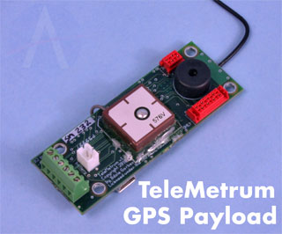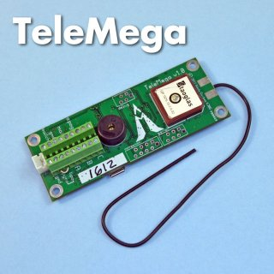

**Required Components**

Teledongle v.3 USB to RF Interface ---------------------------------------------------------------------------------------------------$100.00

<https://www.csrocketry.com/store/search.html?search%5Bkeywords%5D=teledongle+&_a=category> Sold by Chris’ Supplies

<http://shop.gag.com/ground-stations/starter-pack.html> Sold by Altus Metrum

**\*Above sites sell the “Starter Kit” which includes everything listed below except an antenna for the TeleDongle\***

-4 pin MicroMaTch connector for initial programming and debug ------------------------------------------------------------------$3.95

Need help finding cable. Some descriptions state it is included with the Teledongle while others don’t. Closest one I found: <http://netcruzer.com/cab6mm300.html> ($3.95)

-Plastic enclosure 1551 Hammond -------------------------------------------------------------------------------------------------------$14.96

[https://www.toenic.com/us/hammond-1551ptbu-translucent-blue-abs-plastic-project-box-inches-1-58-x-1-58-x- 0-79-mm-40mm-x-40mm-x-20mm.html?gclid=CN3ggYCtl8gCFQQDaQodClkHCg](https://www.toenic.com/us/hammond-1551ptbu-translucent-blue-abs-plastic-project-box-inches-1-58-x-1-58-x-%20%20%200-79-mm-40mm-x-40mm-x-20mm.html?gclid=CN3ggYCtl8gCFQQDaQodClkHCg)

-or **3D Print Enclosure**

850 mAh 3.7 V LiPo Battery (Standard 2 Pin JST Connector) ------------------------------------------------------------------------$10.00

<http://shop.gag.com/parts-and-accessories/850mah-lipo-battery.html> (Sold by Altus Metrum)

<https://www.sparkfun.com/products/341> (Sold by Spark fun)

USB A to B Micro cable (standard android cellphone cable) -------------------------------------------------------------------------$8.00

Sold literally anywhere from around 6-10 dollars.

**Any suitable SMA mount 70cm antenna (recommended by Altus Metrum: Arrow 440-3 Yagi)**

Comet AS-30 (SMA-24) -------------------------------------------------------------------------------------------------------------$24.95

<http://www.americanradiosupply.com/comet-as-30-2m-70cm-superflex-dual-band-ham-radio-ht-antenna-sma/?gclid=CKbI0KG1l8gCFQmnaQodM8sL5Q> Gain and Wavelength: 2.15dBi 1/2 | Wave (70cm) Power Rating: 10 watts Connection: SMA Length: 15 inches

Diamond Antenna (MR75SJ) ------------------------------------------------------------------------------------------------------$36.95

<http://www.dxengineering.com/parts/dmn-mr75sj?seid=dxese1&gclid=CLHR5NG2l8gCFQEMaQodRsEJGQ> (Sold by DX engineering) Gain and Wavelength: 3.4dBi 5/8 | Wave (70cm) Power Rating: 35 watts Connection: SMA Length: 20 inches

Yagi Antennas ----------------------------------------------------------------------------------------- Ranges from $80.00 - $200.00

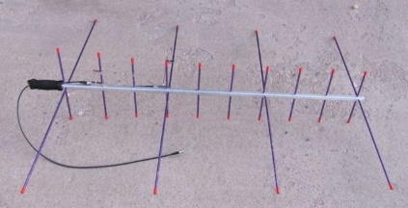Without getting into too much detail the yagi antennas are the handheld booms (fig 1.1) which provide excellent gain upwards from 6.0 dBi to 9.0dBi which is best for a carbon fiber rocket, however, due to the expense it would probably be easier to fabricate our own boom at the EIC.

Fig 1.1

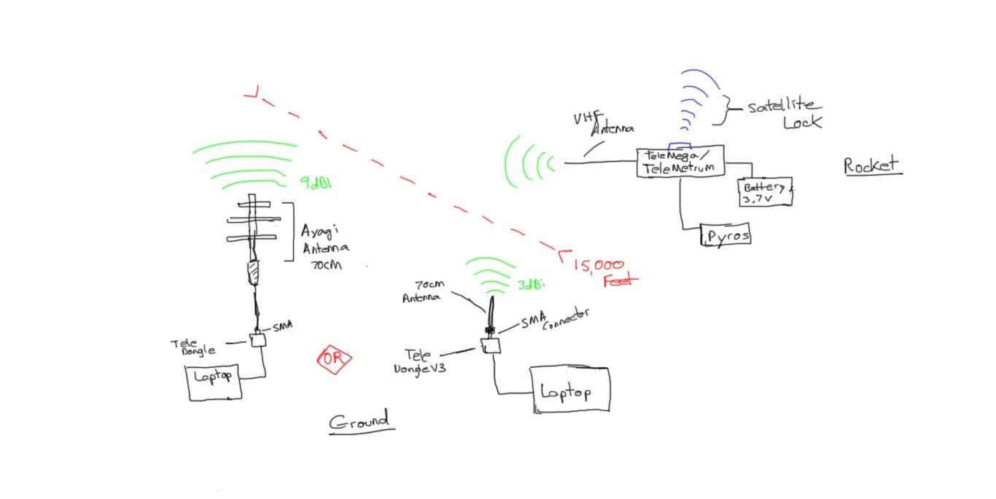Condensed Schematic